21.03.2018, Biała Podlaska

Państwowa Szkoła Wyższa
im. Papieża Jana Pawła II w Białej Podlaskiej
Konkurs “GRA O INDEKS”
na kierunek Neofilologia,
specjalność: język angielski

TRANSFER ALL YOUR ANSWERS ONTO A SEPARATE ANSWER SHEET

I. Read the text and answer questions 1-6, choosing A, B, C or D.

There are many different types of places to eat. One important question is who uses different places and how often they go. As sociologists we are initially very interested in the social and cultural characteristics of people who behave differently. Such characteristics indicate the financial, social, practical and cultural forces systematically distributed across the population, which constrain or encourage people to engage in particular ways of eating out.

We asked respondents how often they ate out under different circumstances. Excluding holidays and eating at the workplace, on average the respondents to the survey ate a main meal out on commercial premises about once every three weeks. Twenty-one per cent ate out at least once a week, a further forty-four per cent at least monthly and only seven per cent claimed never to eat out. Mean frequency of eating at someone else’s home was about the same, but a much larger proportion (twenty per cent) never did so. Twenty per cent of respondents claimed never to eat in the home of other family members, and about one third never at the home of friends, very regular eating out with either kin or friends was not very prevalent, but being a guest at a main meal in someone else’s home is part of the life experience of a large majority of the population. There is a strong positive association between being a guest of friends, guest of family and commercial eating out. Opportunities to eat out are cumulative, particularly eating out commercially and with friends.

To be seen in the right places and in attractive company, or at least to let others know that we are familiar with the most exciting or rewarding of experiences, is part of a process of display and performance which contributes to reputation. Early sociologists examining consumption were particularly interested in the claiming and attributing of status through exhibitions of a prestigious style of life. They were particularly concerned with the ways in which individuals established reputations for refinement, superiority and distinction. Consumption patterns reflected social standing, and particularly class position. Eating out is a potential means for such display through the use and avoidance of different venues.

- What interests sociologists about the topic of eating out?
A The types of places that people choose to eat out in.
B The changes over time in patterns of eating out.
C The characteristics of people who chose to eat out.
D The frequency with which people eat out with friends.

- Which of these statements is true, according to the text?
A People eat out more frequently at someone else’s home than in a restaurant.
B People eat out less frequently at someone else’s home than in a restaurant.
C People are more likely to eat out at a friend’s house than at the home of another family member.
D People are more likely to eat out at the home of another family member than at a friend’s house.

- The study found that people who eat out in restaurants
A also eat out at friends’ houses.
B also go on holiday more.
C have a higher income that others.
D are not so close to their families.

- According to the text, why do people eat out?
A Because they do not have enough time to cook.
B Because thy want to meet attractive people.
C Because it is exciting
D Because it enhances their social status.

- What do you think the text will consider next?
A The reasons for the popularity of particular restaurants.
B The relationship between class and type of restaurant preferred.
C The relationship between cost and restaurant popularity.
D How tastes in restaurants differ over time.

- What do you think the book that this extract comes from would be best entitled?
A Eating out.
B Eating in restaurants.
C Eating well.
D 21st century eating.
___/6

II. For questions 7-13, choose 8 words from the text that best match the definitions given.

7.
- to stop someone from doing what they want to do (PARAGRAPH 1)
8.
- at the beginning (PARAGRAPH 1)
9.
- increasing gradually as more of something is added or happens (PARAGRAPH 2)
10.
- common at a particular time, in a particular place, or among a particular group of people (PARAGRAPH 2)
11.
- the buildings and land that a shop, restaurant, company etc uses (PARAGRAPH 2)
12.
- your family (PARAGRAPH 2)
13.
- places where an organized meeting, concert etc takes place (PARAGRAPH 3)
___/7

III. Read the text and fill in the gaps 14-20 with the missing sentences A-H. One sentence is unnecessary.
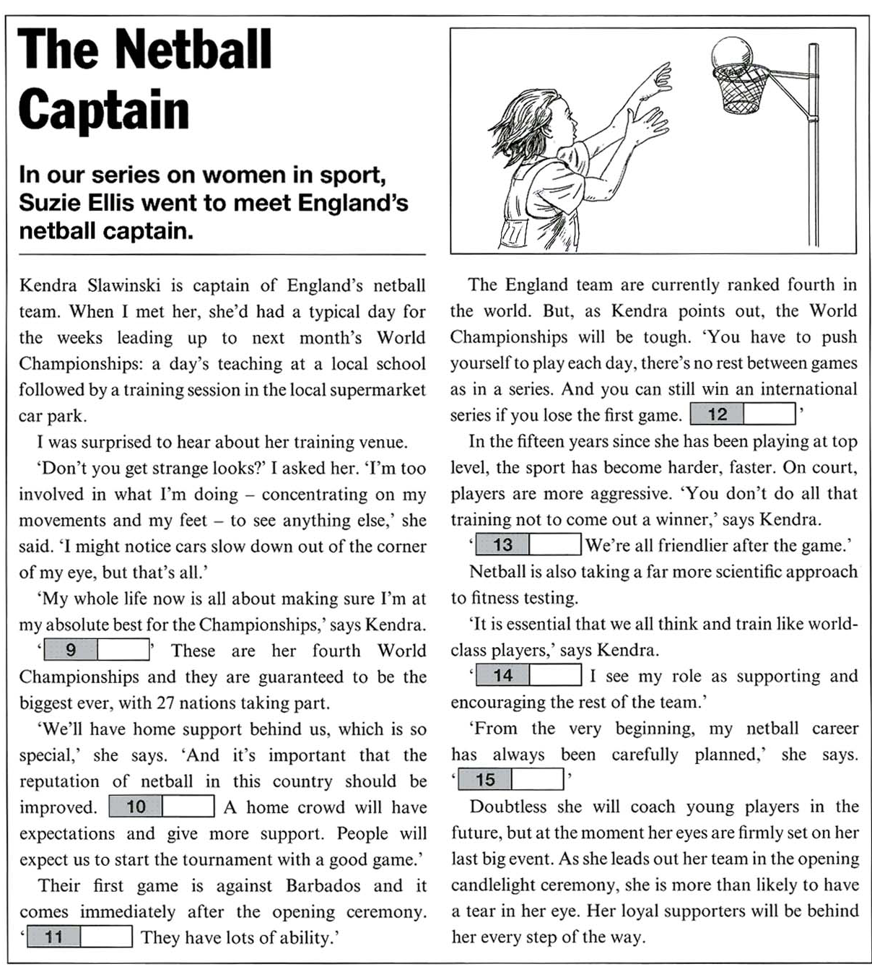
20
19
18
17
16
15
14

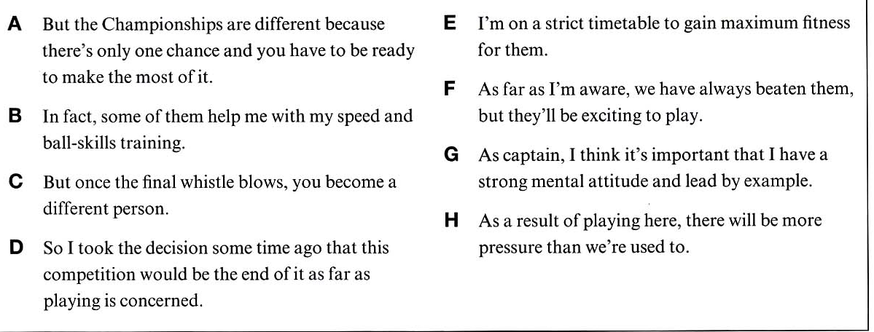
___/7

IV. FOR QUESTIONS 21-35, READ THE TEXT BELOW AND THINK OF THE WORD WHICH BEST FITS EACH SPACE. USE ONLY ONE WORD IN EACH SPACE. THERE IS AN EXAMPLE AT THE BEGINNING (0).

Alcatraz
Situated in the heart (0) …of… San Francisco Bay, Alcatraz Island is, of course, famous (21) ……… its maximum security prison, or ‘penitentiary’, which has been the subject of numerous books and films. Its inmates included some of (22) ……… most notorious criminals in recent American history, such as George ‘Machine Gun’ Kelly, Alvin ‘Creepy’ Karpis and Al ‘Scarface’ Capone, (23) …… spent a total of four and a half years on the island.
The huge concrete cellhouse on Alcatraz was only used (24) ……… a US Federal Penitentiary for 29 years, (25) ……… 1934 until 1963, when the Attorney General, Robert F. Kennedy, ordered it to (26) ……… closed down. Before that period it (27) ……… been home to some of the nation’s military prisoners. The cellhouse (28) ……… built between 1908 and 1911, and many of those who (29) ……… part in its construction – mostly unskilled inmates – became the first prisoners (30) ……… live in it.
During the island’s federal penitentiary days (31) ……… were never more (32) ……… 300 prisoners on Alcatraz at any one time. (33) ……… average, prisoners remained there for about ten years, until (34) ……… were no longer regarded as a danger. (35) ……… no one was ever executed in the prison, eight inmates were murdered and five committed suicide.

___/15

V. FOR QUESTIONS 36-60, CHOOSE THE CORRECT ANSWER.

0. There was no wine left, so they had to …..d….. beer.
a. make up with b. do away with c. do up with d. make do with

36. One ….. adults takes physical exercise at least once a week.
a. from four b. in four c. at four d. with four

37. Mrs Dawson was given the award in ….. of her services to the hospital.
a. spite b. charge c. recognition d. sight

38. Most people ….. ice-cream with the summer.
a. link b. image c. remind d. associate

39. We need to finish the project this week. Can you work …..?
a. overtime b. extra time c. double time d. supplementary time

40. From an early age, Wolfgang had a/an ….. for music.
a. interest b. passion c. involvement d. tendency

41. In answer to my question, my sister ….. in agreement.
a. shook b. grimaced c. wriggled d. nodded

42. The police are concentrating on arresting drug ….. rather than casual users.
a. traffickers b. agents c. merchants d. entrepreneurs

43. Reggae music used to be popular but it’s a bit ….. fashion at the moment.
a. out of b. away from c. beyond d. outside

44. Ouch! I’ve just been ….. by a bee!
a. bitten b. poisoned c. stung d. hit

45. I’m sorry that I giggled so much. I was in rather a silly ….. .
a. temper b. feeling c. outlook d. mood

46. The film didn’t really ….. our expectations, unfortunately.
a. meet with b. fall short of c. put in for d. come up to

47. When Bill saw my new car he was ….. with envy.
a. blue b. green c. yellow d. white

48. With the end of childhood, and the beginning of ….. , young people experience profound changes.
a. teenage b. infant c. middle age d. adolescence

49. We were just having a friendly ….. about football.
a. chat b. whisper c. gossip d. speech

50. The work is beyond the shadow of a ….. one of the best she has written.
a. criticism b. contradiction c. doubt d. suspicion

51. I didn’t go to the concert as I felt a bit under ….. .
a. the water b. the weather c. the clouds d. the blankets

52. People are often surprised that the British do not carry ….. .
a. identity cards b. identity c. identifications d. identities

53. My car has broken down, so I ….. to work these days.
a. walk b. am walking c. was walking d. walked

54. In two years’ time I ….. this book.
a. will finish b. finish c. have finished d. will have finished

55. The price of petrol ….. by 15% over the past year.
a. has been rising b. had risen c. has risen d. risen

56. These shoes were ….. expensive than I wanted to pay.
a. bit more b. further c. far more d. not as

57. He won’t pass the exam …. he studies a lot more.
a. if b. unless c. when d. while

58. I didn't feel like going to the party. I ….. an excuse.
a. I wish I made b. should do
c. should’ve made d. should’ve make

59. Her parents are very proud. She ….. a fantastic job in a law firm.
a. been offered b. offered
c. is offered d. ‘s been offered

60. I ….. sharing a flat but now I prefer to live on my own.
a. used to like b. would like c. never use to like d. never used to
___/25

VI. FOR QUESTIONS 61-70, COMPLETE THE SECOND SENTENCE SO THAT IT HAS A SIMILAR MEANING TO THE FIRST SENTENCE, USING THE WORD GIVEN. DO NOT CHANGE THE WORD GIVEN. YOU MUST USE BETWEEN TWO AND FIVE WORDS, INCLUDING THE WORD GIVEN. THERE IS AN EXAMPLE AT THE BEGINNING (0).

- Airlines don’t allow smoking on planes. PROHIBITED
It is prohibited to smoke on airplanes.

- It's a long time since he last visited grandpa. FOR
He………………………………………………………………………….. a long time.
- He prefers growing plants to growing trees. GROW
He prefers to………………………………………..................................……….. trees.
- The children can't wait to meet their new neighbours. FORWARD
The children can't …………………………….............………… their new neighbours.
- I'm sure Ron is doing his homework now. MUST
Ron …………………………………...........……………………… his homework now.
- Lucy and Clara look the same to me. TELL
I ………………………………...........................................… between Lucy and Sarah.
- She invited five workmates to the dinner, but none of them were able to come. WHOM
She invited five workmates to the dinner, ……………….…………………... to come.
- Mary seems to need some help with the children. THOUGH
Mary looks …….…………………………………...…… some help with the children.
- The cleaner is tidying the couple's room for them. HAVING
The couple ………………………………………….........………………………tidied.
- “Don't forget to book two tickets for the opera”, she said to him. REMINDED
She ……………………………………………………………two tickets for the opera.
- Pam didn't play in the match because she twisted her ankle. WOULD
If Pam hadn't twisted her ankle, she ……….............………….………… in the match.

___/10

VII. for questions 71-80, READ THE TEXTS BELOW. USE THE WORD GIVEN IN CAPITALS AT THE END OF EACH LINE TO FORM A WORD THAT FITS IN THE SPACE IN THE SAME LINE. THERE IS AN EXAMPLE AT THE BEGINNING (0).

Make Money From Being on TV  You can make a career from 0. real television. Some of these television programmes will pay for an 71.______ on their shows, others will reward the winners. Your 72.______ depends on the performance you make, because these shows are all about 73.______. You may even get a chance to appear on other shows. One star of Castaway, for example, has a regular job in a big London 74.______.  However, there are 75.______, too. In a programme like Pop Idol you have to beat the other 76.______ and in shows like Big Brother, the producers will be filming you around the clock. At some stage you will probably be saying something you are not 77._____ proud of. Nobody other than the 78._____ will know how serious the situation was. If you are 79._____ you may become famous, but it will not be the kind of 80.______ you want. | (REALITY)  (APPEAR)  (SUCCEED)  (ENTERTAIN)  (MUSIC)  (ADVANTAGE)  (COMPETE)  (PARTICULAR)  (CONTEST)  (FORTUNE)  (FAMOUS)

___/10

TRANSFER ALL YOUR ANSWERS ONTO A SEPARATE ANSWER SHEET

