Youth exchange project
“Unseen All Ukraine”

10/11 – 17/11/2014
Lviv and Lutsk regions, Ukraine

DESCRIPTION:
European democracy development center (Lithuania) will conduct international youth exchange "Unseen All Ukraine" on the 10-17th of November 2014, in the Lutsk and Lviv regions of Ukraine. In this project will participate youth from Lithuania, Ukraine, Turkey, Italy, Cyprus, Bulgaria, Romania, Georgia, Hungary, Slovakia, Poland and United Kingdom. Totally in this youth project will take a part 4 young people (18-25 y. o.) and 1 group leader from each country (60 people).
The idea of this project was created by the young people in the open discussion in the social network and it was developed by the Ukrainian and Lithuanian youth organizations.
The main aim of the project is: to show for EU and Eastern partnership countries the unique Ukrainian culture, arts and traditions.
The main tasks of the project: to create the cooperation networks between project partners, promotion of multilingualism, youth patriotic education, promotion of the communication in cross-cultural environments, increase the youth initiative and leadership, youth tolerance between cultures promotion, better understanding of European citizenship, volunteering and bigger involvement into the community stimulation.
Project participants will involve in each project period: preparation, active activities and dissemination and this will be coordinated by the each group leader. In this project participants will make such activities as(in Lutsk and Lviv region villages): creative presentations of each country history, culture, crafts and traditions, youth will make traditional Ukrainian food and will make traditional embroidery and weaving, also will sing and dance traditional Ukrainian songs and dances, will ride, throw the lance and will participate in the meetings with villages communities and it's active members with whom will be made the discussions in the different topics. During the project will be used this non-formal education methods: games, debates, discussions, presentations, performances and different creative exercises. The main results of this project - movie about Ukrainian culture, arts and traditions and project presentation will be presented in every EU and Eastern partnership country, in order to present it in the huge publicity.
After this project we expect that project participates will better work in cross-cultural teams, tolerate other cultures and religions and will start to be more interested in the other countries cultures, will improve their leadership and creative skills, will better realize the citizenship and patriotic aspects, will induce the youth volunteering and involvement into communities and the promote multilingualism. Is expected that this project will be continuous and will be made in the countries, which are also by the integration to the European Union, such a Georgia and Moldova.
DATES:

The project will be held in 10 – 17 November 2014.
• Arrival day to Lviv (Ukraine) is the 10th November.
• The end of the activity will be in the evening of the 16th November.
• Departure day is the 17th of November

According to the guidelines of Erasmus + program the travel back must be realized by participants on direct way within maximum of 2 days. In case of longer stays or indirect travel (holiday travel, etc) will be NO reimbursement.
PARTICIPANTS:

The target group is representatives of youth organizations (youth leaders, youth
workers, volunteers, multipliers).
They also should:
- Be 18-25 years old;
- be able to actively involved in the project;
- be motivated and able to attend the exchange for its full duration;
- be able to work in English.

VENUE:
The youth exchange will be held in Lviv and Lutsk regions, Ukraine (650 km from Kiev).
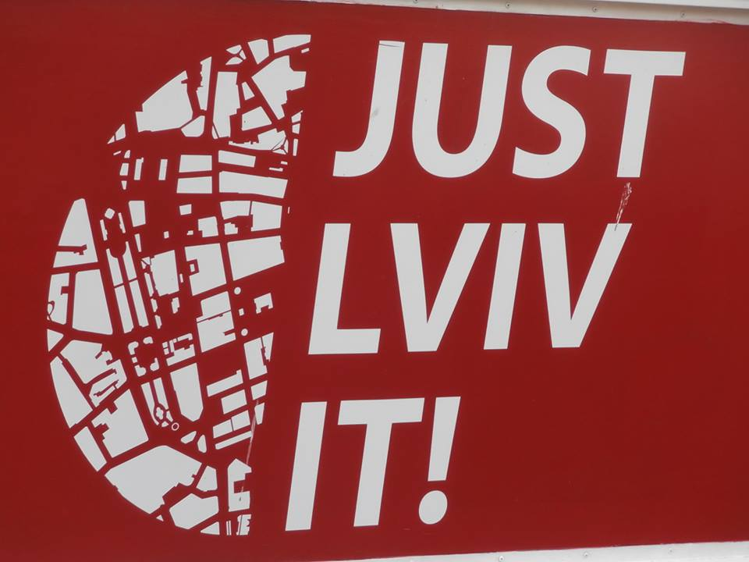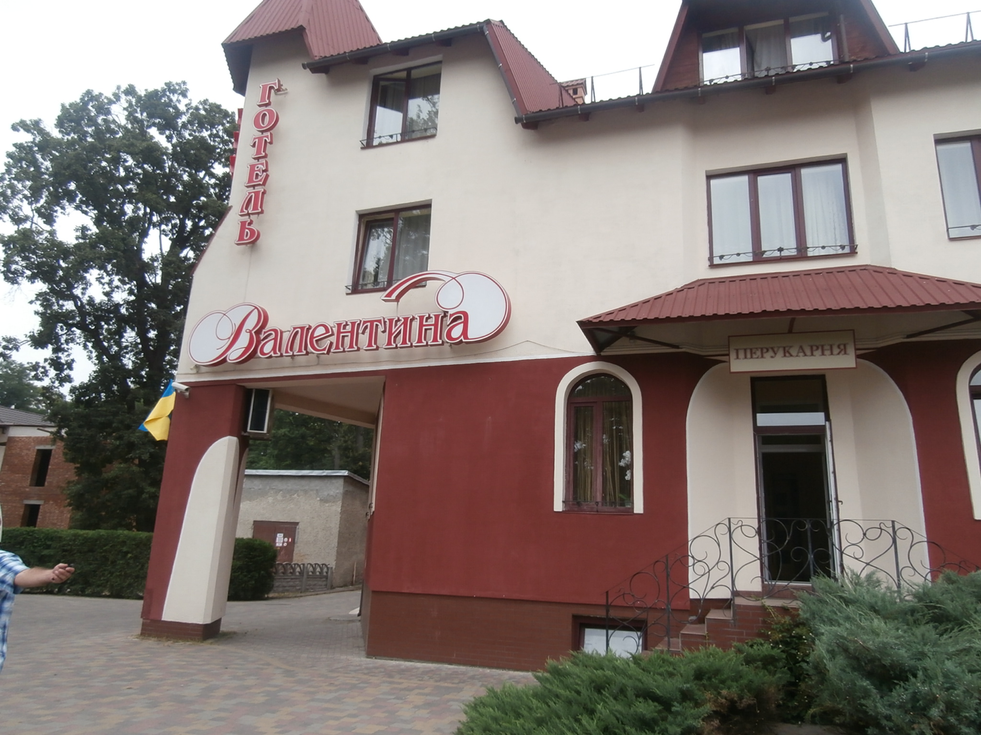
Hotel “Valentina” – It’s a small hotel, located 5 km from Lviv center.
http://valentyna-hotel.virtual.ua/?lang=en
In the accommodation each bedroom will have 2 -3 beds. There is shower, hot water, toilet per 1 room.
3 meals for day will be covered. Breakfast you will have in a hotel and lunch/dinner you will have in the project place.
There is wi-fi in every room.
The shops and restaurants are near this hotel. In the hotel there is also restaurant.

BE SURE the venue is selected in an area away from any war activities (more than 800 km). Organizers of the project will provide maximum comfort and safety for all of participants of the project. Your safety and security are the mainest priorities for us.

HOW TO GET TO THE HOTEL:

Participants need to fly to Kiev on 9th of November or 10 th of November morning/afternoon and take the train to Lviv. The train schedule you can look in the Ukrainian trains website: http://www.uz.gov.ua/en/Once again want to remind you to take the cheapest air or train Tickets to reach Kiev or directly Lviv, because of the first payment of project just 65%.
And the departure day is 17 th November. On this day we can take the train from Lviv to Kiev and in the afternoon have flights home or going by train during the night and in the morning 18th Nov have flights. Train can be expresses which are going from Lviv-Kiev (5 hours) or normal trains which are going per night (12 hours). Check in their website.

We will rent a bus for all participants, which will meet the participants on date 10 Th Nov and will bring to the hotel “Valentina”. During the project we will have one big bus.
After you will know your arrival times please inform us and we will arrange your meetings.

TRAVEL COSTS:

If you find tickets, which cost will be not more than budget from project to your countries participants, all your travel expenses will be covered by the organizers with the support of Erasmus +. If you find tickets, which cost is more than budget from project you have to prepay for organizers the difference.
In order to receive the money for the transportation, please keep your original invoices, receipts, tickets, boarding-passes or any other transport document (if you buy ticket online, you must pring payment proof from your bank, and if you buy by cash you must bring payment receipt). So you can give us all these documents. Without all these documents will be NO reimbursement.

Please note that the price of the tickets shall be within the budget limits set for this program (in Euro):

Country | Persons per country | Total travel cost for 1 person (100%) in Euros, and (65 %) | Totally for traveling for 5 participants 100 % and (65 % which we will get till the project start)
Lithuania | 5 | 170 (110,50) | 850.00 (552,50)
Poland | 5 | 170 (110,50) | 850.00 (552,50)
Turkey | 5 | 170 (110,50) | 850.00 (552,50)
Ukraine | 5 | 20 (13,00) | 100.00 (65,00)
Romania | 5 | 170 (110,50) | 850.00 (552,50)
Italy | 5 | 170 (110,50) | 850.00 (552,50)
Hungary | 5 | 170 (110,50) | 850.00 (552,50)
Bulgaria | 5 | 170 (110,50) | 850.00 (552,50)
Cyprus | 5 | 170 (110,50) | 850.00 (552,50)
UK | 5 | 270 (175,50) | 1350.00 (877,50)
Slovakia | 5 | 170 (110,50) | 850.00 (552,50)
Georgia | 5 | 170 (110,50) | 850.00 (552,50)
Totally | 60 participants |  | 9950,00 (6467,50)

PREPARATION:

- comfortable and waterproof shoes for the outdoor programs;
- materials about your organization for NGO Market;
- your original tickets for the entire trip, the invoice of the travel agency (the price clearly indicated on the ticket), the boarding passes;
- your travel insurance contract and a legible copy of it;
- your passport and two clearly legible copies of it; Passport have to be valid no less than 6 months from the departure day.
- your own medication;
- typical things about your country such as food, drinks, flag, music, traditional objects for Intercultural evening;
- music for the Disco party;
- good mood.

All your questions sent:
Julija Mackevic europroject2009@hotmail.com

Find me in facebook: https://www.facebook.com/julija.mackevic
Find project Unseen All Ukraine group and follow the news:
https://www.facebook.com/groups/1520078364890065/

