IES Consulting
Talent Searchers Providing Experiences
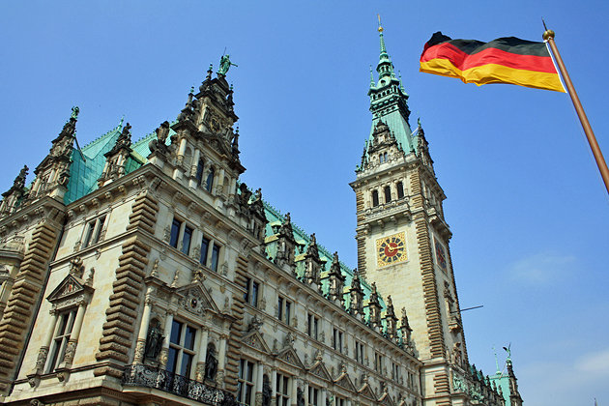

Product Management

& Service (Polish Native)

WHERE? Hamburg,Germany
WHEN? Start date flexbile
DURATION: 3 months minimum
HOW MANY HOURS? full time, 40h/week
Our client company is an online company in the touristic sector. Their main business concentrates on a comparison website for rental cars in Europe. Settled in Hamburg you will be part of a young and dynamic team in which you will get the chance to propose your own ideas and take part in the creation of a new website for the Polish market.
The tasks are varied:
- During your internship your will pass the following tasks:
- checking and changing offers at the website
- enlarge the product portfolio
- contact person for the clients
- learn to work with Content Management Systems
- deep insights in the online travel market and Online Marketing
- possibility to propose your own ideas to improve the marketing strategies
PLEASE NOTE:
- voluntary internships (maximum 3 months)
- compulsory internships (minimum 3 months)

We are looking for:
- Studies: Business, Tourism, Hospitality, Languages
- Languages: Polish (native), German (B1/B2)
- We offer:
- Remuneration: 500€/month
- Interesting tasks, international and pleasant work environment
APPLY NOW! Please send us your CV in English or Spanish on praktyki@ies-consulting.es or register on our website http://www.ies-consulting.pl/formularz_dla_studenta.php

* Our recruitment process is free. Only if you got accepted and the company will confirm your application we require administration fee. All our internships provide salary, so we guarantee that costs of the services will pays off.

